**Information System Management Lab**

**BCOM 307**

**Assignment #19**

***Submitted by:***

**Name:** YASH JAIN

**Enrollment No:** 03914788818

**Semester:** B.Com(H) 5th Semester

**Class:** B.COM(H)

**Section:** B.Com 5A

**Date of Submission:** 18/10/2021

***Submitted to:***

**Praveen Kumar Singh**

**Assistant Professor, MAIMS**



**Department of Commerce**

**Maharaja Agrasen Institute of Management Studies**

**Affiliated to Guru Gobind Singh Indraprastha University, Delhi**

**Sector -22, Rohini, Delhi -110086, India; www.maims.ac.in**

Maharaja Agrasen Institute of Management Studies

Affiliated to GGS IP University; Recognized u/s 2(f) of UGC Recognized by Bar Council ofIndia; ISO 9001: 2015

Certified Institution Sector 22, Rohini, Delhi -110086, India; [www.maims.ac.in](http://www.maims.ac.in/)

Department of Commerce

Academic Year: 2020-21

Semester: Vth

# Assignment No. 19

# Unit No:

**Course/Subject Code:** BCOM 307 **Subject Title: Information System Management Lab**

# Issue Date Last Date of Submission:

**Instructions for Students:**

# All Questions are Compulsory.

1. The student should attach proper cover page for each assignment clearly mentioning the Assignment No.
2. Each assignment should be prepared by the student individually with proper explaination and screenshots.
3. A4 size ruled sheets should be used for the assignment.
4. Assignment pages should be serially numbered at the bottom of page.

***During online education mode, upload scanned copy of the complete assignment including cover page latest by due date.***

|  |  |  |
| --- | --- | --- |
| **Question No.** | **Question** | **CO No.** |
| 1 | Find the average salary of the employees from the employees table. | **CO1, CO2, CO3, CO4**  **CO1, CO2, CO3, CO4** |
| 2 | Find the minimum salary and the maximum salary of the employees table. |
| 3 | Find the sum of commission of the employees table. |
| 4 | Display the average salary of employees whose hire date is greater than 01-01-1960. |
| 5 | List the names of all the employees with salary greater than equal to 2000 and commission greater than equal to 200. |
| 6 | List the names of all the employees having ‘a’ as second letter in their names, and salary greater than equal to 1000. |
| 7 | Count the number of employees having commission less than 500. |
| 8 | Determine the maximum and minimum commisssion of the employees table, and rename the output as ‘Max_Comission’ and ‘Min_Commission’. |
| 9 | List the employees whose salary is more than 1000. Calculate a new salary as original salary*0.15, and rename the output as ‘new salary’. |

**ASSIGNMENT 19 - PRACTICE QUESTIONS**

**Task 1 : Find the average salary of the employees from the employees table.**

This task can be completed using the **AVG( )** aggregate function.

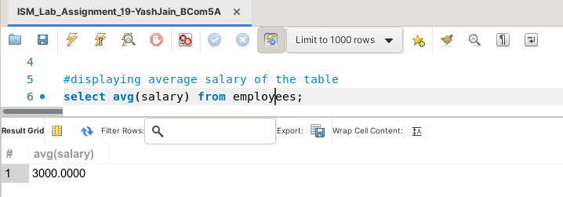

**Task 2: Find the minimum salary and the maximum salary of the employees table.**

This task can be completed using the **GROUP BY** clause, the **WHERE** clause and the **MAX( )**, and **MIN( )** aggregate functions.

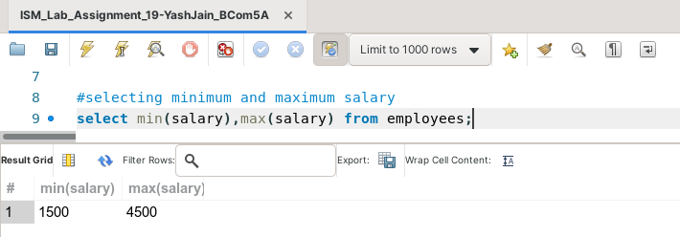

**Task 3: Find the sum of commission of the employees table.**

This task can be completed using the **SUM( )** aggregate function.

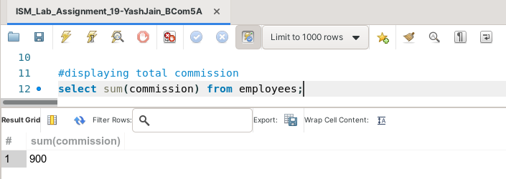

**Task 4: Display the average salary of employees whose hire date is greater than 01-01-1960.**

This task can be completed using the **AVG( )** aggregate function, along with the **WHERE** clause.

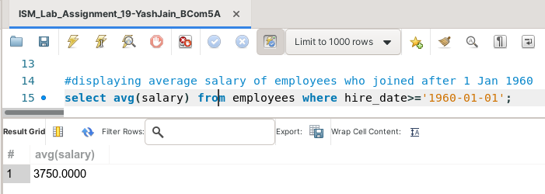

**Task 5: List the names of all the employees with salary greater than equal to 2000 and commission greater than equal to 200.**

This task can be completed using the **AND** operator, and the **WHERE** clause.

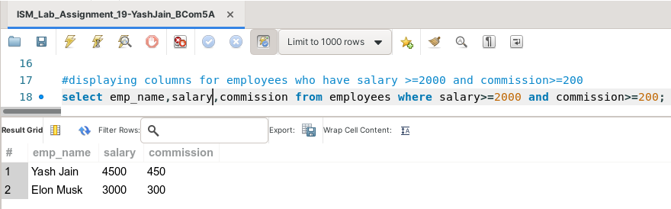

**Task 6: List the names of all the employees having ‘a’ as second letter in their names, and salary greater than equal to 1000.**

This task can be completed using the **AND, LIKE** operators, and the **WHERE** clause.

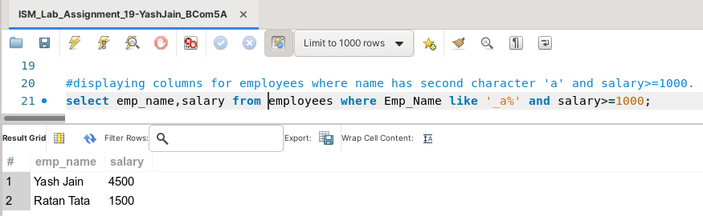

**Task 7: Count the number of employees having commission less than 500.**

This task can be completed using the **COUNT( )** aggregate function, along with the **WHERE** clause.

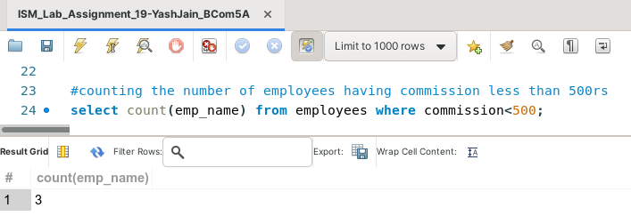

**Task 8: Determine the maximum and minimum commisssion of the employees table, and rename the output as ‘Max_Comission’ and ‘Min_Commission’.**

This task can be completed using the **WHERE** clause and the **MAX( )**, and **MIN( )** aggregate functions.

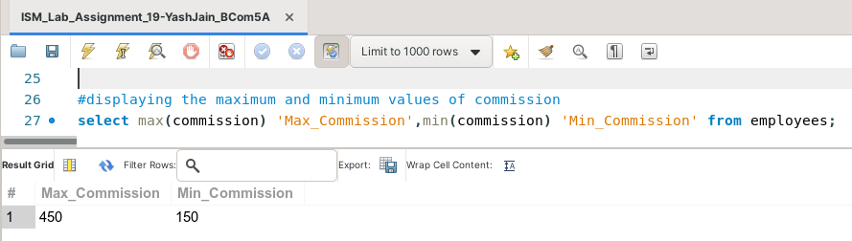

**Task 9: List the employees whose salary is more than 1000. Calculate a new salary as original salary*0.15, and rename the output as ‘new salary’.**

This task can be completed using the **WHERE** clause.

